PURPOSE
This Standard Operating Procedure (SOP) outlines the process for requesting and managing changes to computerized systems utilized by Netramind for GxP activities.

SCOPE
This procedure applies to significant changes made to controlled or production computerized systems used in support of GxP-regulated activities.

REFERENCES
SOP-013 Computer System Validation
SOP-004 GxP Records Retention
European Medicines Agency (EMA): Guideline on computerized systems and electronic data in clinical trials
Food and Drug Administration (FDA): 21 CFR Part 11; 21 CFR parts 210 and 211 and 820
International Conference on Harmonization (ICH) Q7: Good Manufacturing Practice Guide for Active Pharmaceutical Ingredients; November 2000
International Conference on Harmonization (ICH) E6 (R3) Good Clinical Practice
GAMP 5: A Risk-Based Approach to Compliant GxP Computerized Systems

DEFINITIONS

Change Control—Change Control is a general term describing the process of managing how changes are introduced into a controlled system.

Change Control Form (CCF)— An official request for prospective approval to implement a change to a validated system.

Change Record—Documentation associated with a proposed and implemented change to a controlled computerized system.

RESPONSIBILITIES

IT Manager or Designee

A Change Originator initiates the change control and provides justification for the Change. The IT Manager / Designee ensures that changes made to computer systems, for which they are responsible, follow this change control procedure.

Authorize the testing and implementation of the change.

Ensure change control is closed prior to production use.

Arrange downtime requirements to implement the changes in production.

Change Control Coordinator or Designee

Manages review and approval of the change control with appropriate signatures.

IT Quality Assurance (QA) or Designee

QA is responsible for review and approval of the impact assessment and oversight of the change operation.

PROCEDURE

Information Technology (IT) Change Control Process

The IT Change Control process is used to manage significant changes to controlled or production computerized systems supporting GxP activities.

The change control is documented appropriately using FRM-012-01 IT Change Control Form.

The IT Manager / Designee ensures that the changes are deployed to the production environment and that there is minimum disruption to the services.

The individual initiating the change documents the proposed change and associated justification.

The Change Request Form contains:

Change NO—A unique change control number must be filled in. QA should be contacted to get change control registered and for the Unique Change Control number.

Change Originator / Department

Date of Request

Application Name—The name of the application that requires the change should be documented.

Change Type—One of the following must be selected:

Standard: This should be checked when the change is according to a pre-arranged schedule of a change window and such changes could be recurring types.
Emergency change: An emergency change is used in response to a system failure that impacts personal safety. GxP compliance and/or critical business operations. Emergency changes require expedited review and approval as appropriate prior to implementation where feasible

A detailed description of the change and justification for change

Change Implementation Plan

A detailed back-out plan for unsuccessful attempts to implement the changes

Schedule of the implementation

Environment location—All the environments where the change will be implemented will be documented in this section

Impact of the change—Originator documents the impact of change and sends it for review

Impact Assessments may consider:
System functionality, security, and data integrity
Interfaces
Validation status
User impact

CCRB Review and Approval

Change Request Status

Verification that the change was successfully implemented

Requestor and approver sign-off

The following flowchart explains the change control process:

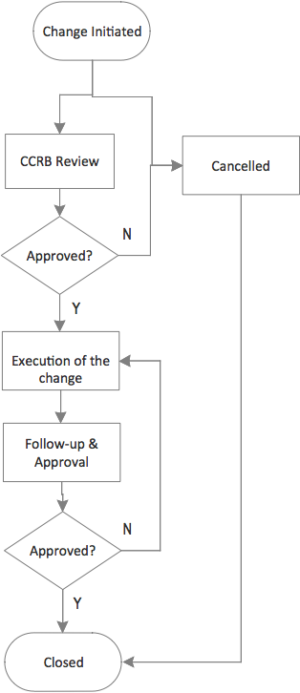

Approved changes are implemented according to a documented implementation approach that may include testing, deployment, rollback considerations, and documentation updates where applicable.

Once the implementation plan has been created, the IT Manager ensures that:

Confirm that documents, SOP’s, forms, etc. impacted by the change have been revised and approved.
Relevant SOPs, documentation, and training materials are updated where appropriate.

QA reviews significant changes to ensure appropriate documentation, testing, and approvals are completed prior to closure.

All the forms and change control related documentation is filed as per the SOP-004 GxP Records Retention.

ATTACHMENTS
FRM-012-01 IT Change Control Form

Revision History
Version Number | Date | Summary of Change(s)
01 | 22-MAY-2026 | New Document
[X.0] | [DD-MMM-YYYY] | [Insert a summary of the changes]

Signature Page

[Add additional rows as needed]
Author:
Name | Title | Signature | Date
Justin Shaka | Fractional COO

Reviewer:
Name | Title | Signature | Date
Jay Chhablani | President

Approver:
Name | Title | Signature | Date
Sandeep Chandra Bollepalli | Director of AI

